**The Story of Phillis Wheatley**

*Written by L.S. Choudhury*

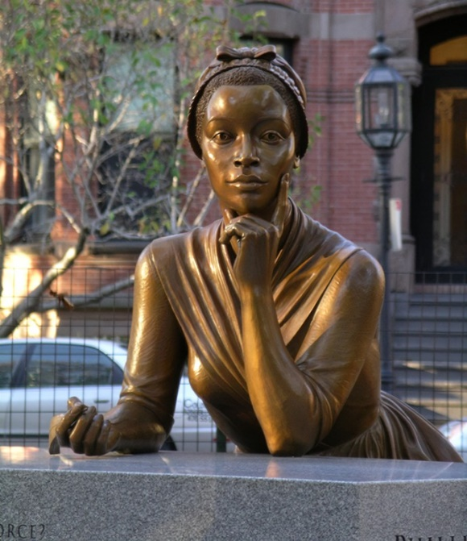Some of the greatest poets have their names engraved in history. Within education, words of praise are sung to us about famous literary artists such as Percy Shelley, William Blake, Seamus Heaney, and William Wordsworth. Though they are incredibly talented poets, I have chosen to not delve deeper into my research in regard to their work because I would like to shine light on another. Since the occurrence of international women’s day, which is held every year on the 8th of March, as well as the ‘We Can Do It’ event, I would also like to participate in my own share of educating others on powerful women. My interest in this particular individual has grown positively progressive since the very day her name was mentioned to me; she holds great importance in representing black women historically and I believe that she is an honourable figure to both praise and look up to in modern times. Phillis Wheatley was an 18th century poet who, despite her heart-wrenching experiences of having to lead a life which she was forced into, managed to achieve such an incredible milestone.

Born in 1753, in the region of the western African continent, Phillis Wheatley was a brave, young girl who unfortunately, at only seven years of age, had to suffer the horrific fate of being sold to an American trader; she was forced into the Transatlantic slave trade. Being treated as a commodity was the common experience that many African people had fallen victim to, and Wheatley was no exception to the harsh treatment she endured. Her story of her inspiring path to poetry began when she arrived in Boston, Massachusetts, which is located around the north-eastern region of the United States, where she was purchased by the wealthy Boston merchant and tailor, John Wheatley; she was intended to fulfil her role as a slave for his wife Susanna Wheatley. The Wheatleys used the forename Phillis, which was after the vessel that had transported her to North America and was given the family surname Wheatley.

The Wheatleys had a daughter named Mary. Due to Phillis being illiterate, Mary became her first tutor in reading and writing and their son, Nathaniel, had also tutored her. When conducting my research, I had learned that John Wheatley was known in Boston as a ‘progressive’ individual, meaning that he would personally advocate for the education of African Americans, through Phillis also held less racial and gender prejudice against black individuals and women. It was a positive change to learn that the Wheatleys were able to provide Phillis with an unprecedented education, which was uncommonly seen for an enslaved person, and also one that was highly unusual for a woman of any race during that time. Brilliantly, Phillis, at only twelve years of age, had learned to read Greek and Latin classics in their original languages, as well as exceedingly academically challenging passages from the Holy Bible. It would only be two years later, when the talented teenage girl would write her first poem, "To the University of Cambridge, in New England".

To the University of Cambridge, in New England:

While an intrinsic ardor prompts to write,

The muses promise to assist my pen;

’Twas not long since I left my native shore

The land of errors, and Egyptian gloom:

Father of mercy, ’twas thy gracious hand

Brought me in safety from those dark abodes.

Students, to you ’tis giv’n to scan the heights

Above, to traverse the ethereal space,

And mark the systems of revolving worlds.

Still more, ye sons of science ye receive

The blissful news by messengers from heav’n,

How Jesus’ blood for your redemption flows.

See him with hands out-stretcht upon the cross;

Immense compassion in his bosom glows;

He hears revilers, nor resents their scorn:

What matchless mercy in the Son of God!

When the whole human race by sin had fall’n,

He deign’d to die that they might rise again,

And share with him in the sublimest skies,

Life without death, and glory without end.

Improve your privileges while they stay,

Ye pupils, and each hour redeem, that bears

Or good or bad report of you to heav’n.

Let sin, that baneful evil to the soul,

By you be shunn’d, nor once remit your guard;

Suppress the deadly serpent in its egg.

Ye blooming plants of human race divine,

An Ethiop tells you ’tis your greatest foe;

Its transient sweetness turns to endless pain,

And in immense perdition sinks the soul.

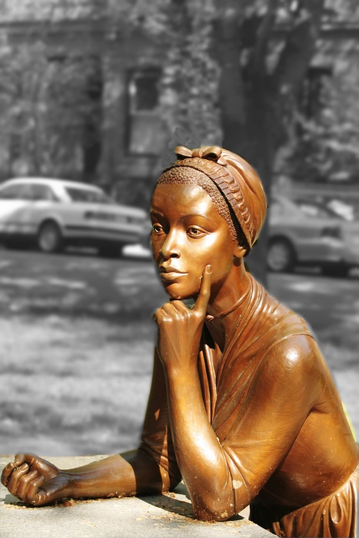The first poem that Phillis Wheatley had written was a delight to read; I believe that within the poem, she highlights the utmost importance of recognizing Jesus Christ and his most loving sacrifice, to be crucified. It is a crucial moment in his life as this brave, benevolent act brought humans salvation from sin. Even though Phillis had no prior university education, her target audience were students who were attending Harvard College. On one hand, she understands the importance of the vast arrays of education that the students had learned from their time as undergraduates, but she maintained that they must understand the most important lesson that they will ever learn. Wheatley says to avoid the allurement of sin in order to honour Jesus Christ and his ultimate sacrifice for salvation, the deliverance from humankinds sin.

The Wheatleys had quickly recognized her remarkable literary ability and had supported Phillis's education; she stopped doing domestic work and was encouraged to pursue literature. The Wheatleys had often exhibited Phillis's abilities to friends and family. Phillis, through her literary studies, was influenced by the works of other famous poets such as Alexander Pope, Horace and Virgil and John Milton. Her works were recognised when she made a visit to London, England, initially for her health due to being diagnosed with chronic asthma. During her visit, she gathered an audience of influential people, one memorable lady was Selina Hastings, Countess of Huntingdon, who became interested in Phillis’s talent in poetry to which she subsidized, supported financially, the publication of Wheatley's volume of poems. Her poetry appeared in London in the summer of 1773, and she was manumitted, becoming a freed woman from slavery, from the Wheatleys during November of that same year.

Wheatley influenced the way people would perceive black individuals to such a great extent. Voltaire, who was a French Enlightenment writer, historian, and philosopher would state in a letter that Wheatley had proved that black people could write poetry. As well as that, she was highly honoured by many of the founding fathers from the United States. After writing a poem in the honour of him, George Washington wrote to Phillis, regarding her incredible poetry "the style and manner exhibit a striking proof of your great poetical talents”. Wheatley and her literary works are truly important and fundamental to learn when discovering the great genre of African American literature. She is deservedly honoured as the first African American woman to publish a book of poetry and the very first to make a living from her literary art.

Even though she was a woman of colour, I strongly believe that everyone is able to learn from her story. For women, Wheatleys story encourages women to excel in their passions, despite the setbacks presented, such as toxic gender-norms, that different cultures that, to this day, live by. For all black individuals, Phillis encourages them to be proud of their identity, to not shy away from who they are. On the whole, the amazing poet teaches us to have creative expression. Wheatley proves that anyone from any background should feel free to enter any career path. Despite being a black woman in the 18th century and living in a country that responded to people of her race in a hostile manner, she still achieved great success and positively influenced the prejudicial ideas of African Americans to change. Regrading Phillis personally, she was an amazing poet who I would have loved to meet, her wise words and high intellect drives me to work hard for my own future and education.

CITATIONS

*Wikipedia: https://en.wikipedia.org/wiki/Phillis_Wheatley*